Wipro JAVA Assignments Solution screenshots:

**Assignment1:**

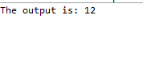

**Assignment2:**



**Assignment3:**

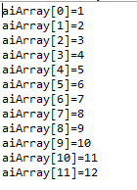

**Assignment4:**



**Assignment5:**



**Assignment6:**

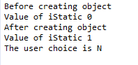

**Assignment7:**



**Assignment8:**



**Assignment9:**

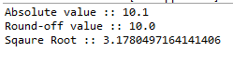

**Assignment10:**



**Assignment11:**

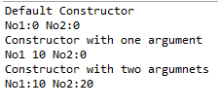

**Assignment12:**



**Assignment13:**



**Assignment14: No Output**

**Assignment15:**



**Assignment16:**

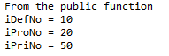

**Assignment17: No Output**

**Assignment18: No Output (Interface)**

**Assignment19:**

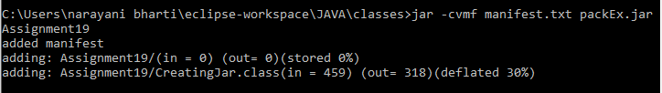

**Assignment20:**



**Assignment21:**



**Assignment22:**

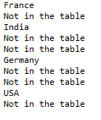

**Assignment23:**



**Assignment24:**

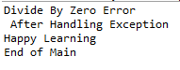

**Assignment25:**

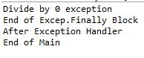

**Assignment26:**



**Assignment27:**



**Assignment28: No Output(Runtime error)**

**Assignment29:**

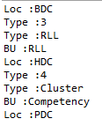

**Assignment30:**



**Assignment31:**

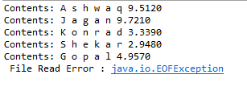

**Assignment32:**



**Assignment33:**



**Assignment34:**



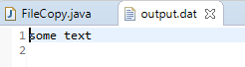

**Assignment35:**



**Assignment36:**

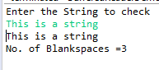

**Assignment37:**



**Assignment38:**

